Project Documentation

Title: Cross-Platform OS Utility Tool

Authors:
- Muhammad Salman (Roll No: F23605083)
- Mian Shakar Afzal (Roll No: F23605073)
- Abdul Mateen Amir (Roll No: F23605111)
- Abdullah (Roll No: F23605090)
- Mohid Asmat (Roll No: F23605096)

Supervisor: Ma’am Shanza Zafar
Date: December 29, 2025

1. Abstract
The Cross-Platform OS Utility Tool is a Python-based desktop application developed to provide essential system utility functions across Windows 10+ and Ubuntu 20.04+. The tool offers features like file cleanup, disk analysis, process management, system monitoring, network information, security scanning, and startup management. By leveraging Python’s Tkinter for GUI and modular OS abstraction logic, the application ensures a consistent user experience across different platforms.

2. Introduction
Modern computer systems require regular maintenance to optimize performance and ensure security. While many OS-specific tools exist, a single utility that works seamlessly across both Windows and Linux platforms is rare. This project aims to fill that gap by creating a cross-platform system utility tool that is user-friendly and capable of performing multiple maintenance and monitoring tasks without relying on third-party software.

3. Objectives
- Develop a cross-platform system utility tool for Windows and Linux.
- Implement core OS functionalities such as file cleanup, process management, disk analysis, and system monitoring.
- Demonstrate OS abstraction to execute platform-specific commands transparently.
- Provide a user-friendly GUI using Python’s Tkinter.
- Integrate system security tools like Windows Defender and ClamAV.

4. Literature Review

Existing system utility tools are usually platform-specific:
- Windows: CCleaner, Task Manager, Resource Monitor.
- Linux: BleachBit, htop, system monitor apps.
Cross-platform solutions are limited and often web-based, which require network connectivity. This project leverages Python’s flexibility to bridge the gap and provide a desktop-based, offline, cross-platform tool.

5. Methodology

5.1 Technology Stack

Component | Technology
Programming Language | Python 3.x
GUI Framework | Tkinter (ttk for modern widgets)
System Calls | subprocess for executing OS-specific commands
OS Detection | platform module to identify runtime OS

5.2 Architecture

The application follows a modular architecture to separate the logic from the interface:
- OS Detection (os_detector.py): Identifies whether the tool is running on Windows or Linux.

- Command Abstraction (command_runner.py): Wraps OS-specific commands (e.g., dir vs ls) to provide a unified interface.

- Action Modules (actions/): Contains functionality for file cleanup, process management, system monitoring, networking, and security.

5.3 Key Features Implementation

- File Cleanup: Deletes temporary files, logs, and caches.
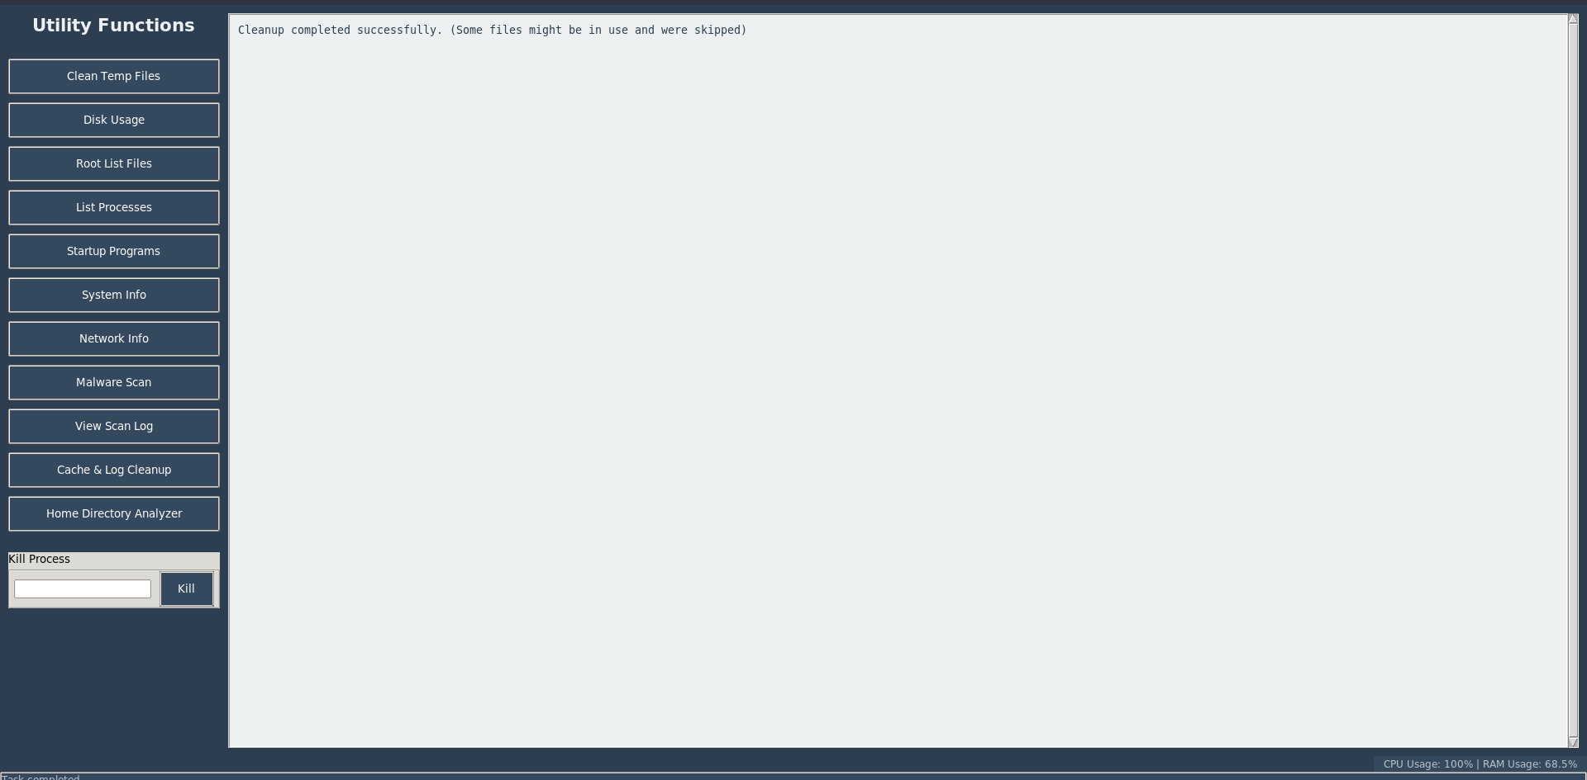
- Disk Analysis: Lists root directory contents, monitors disk usage.
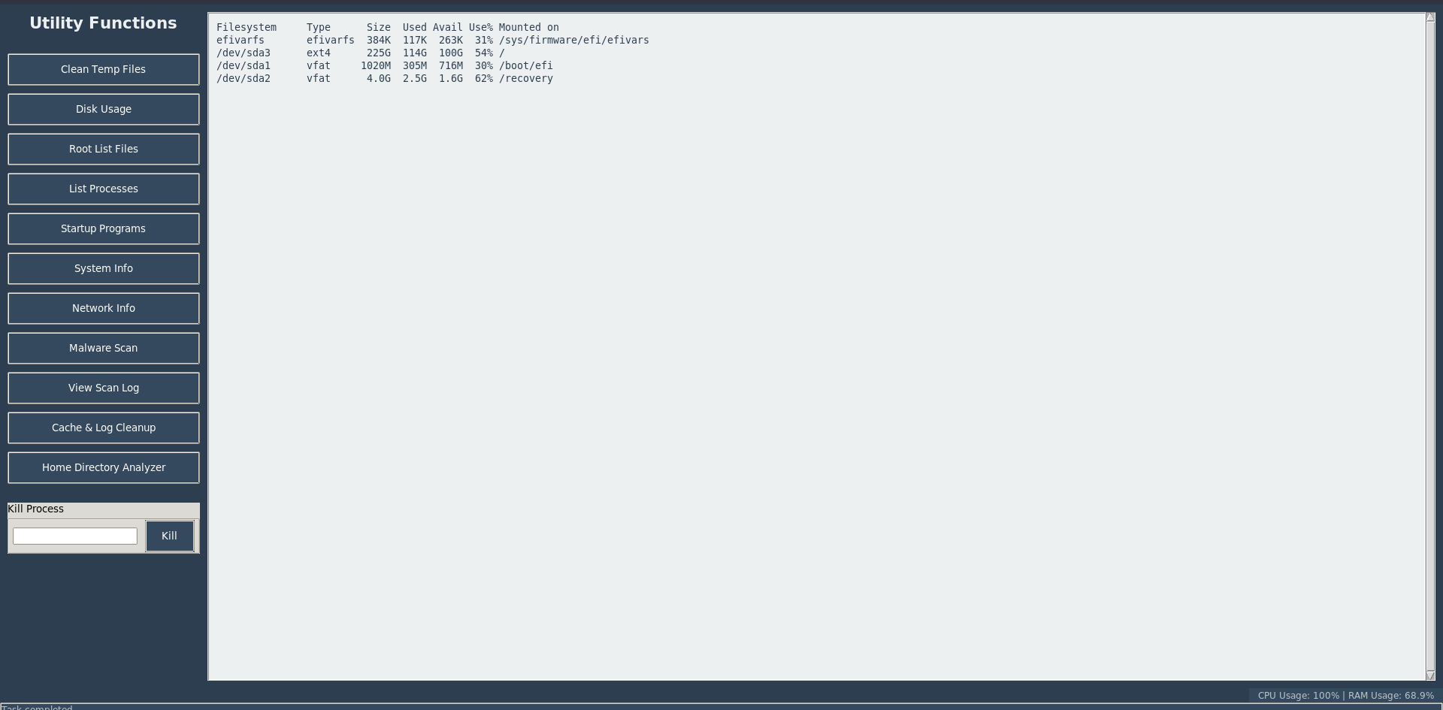
- Process Management: Lists active processes and allows termination by PID.
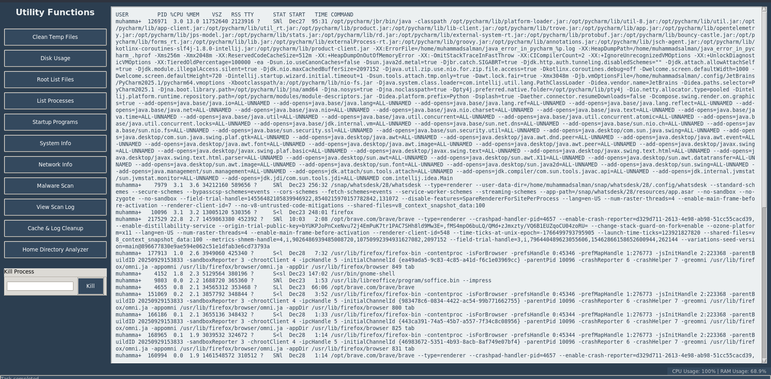
- System Information: CPU/RAM monitoring and hardware info.
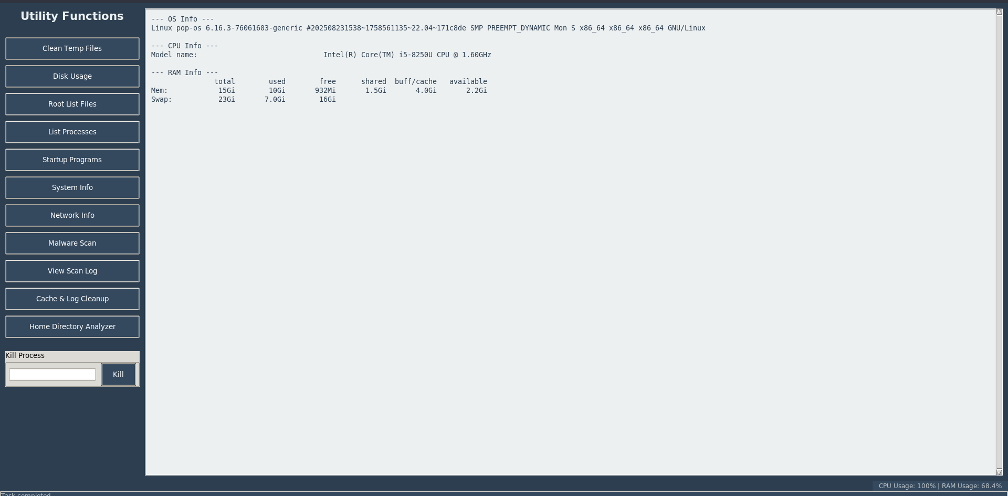

- Networking: Displays IP addresses and network interfaces.
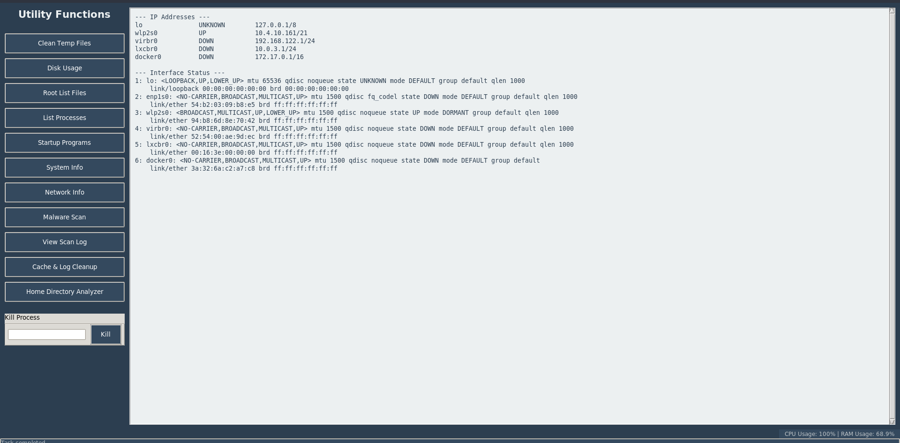

- Security: Integration with Windows Defender and ClamAV.

- Startup Manager: View startup applications.

6. Operating System Concepts Demonstrated
- Process Management: Handling PID-based termination and resource monitoring.
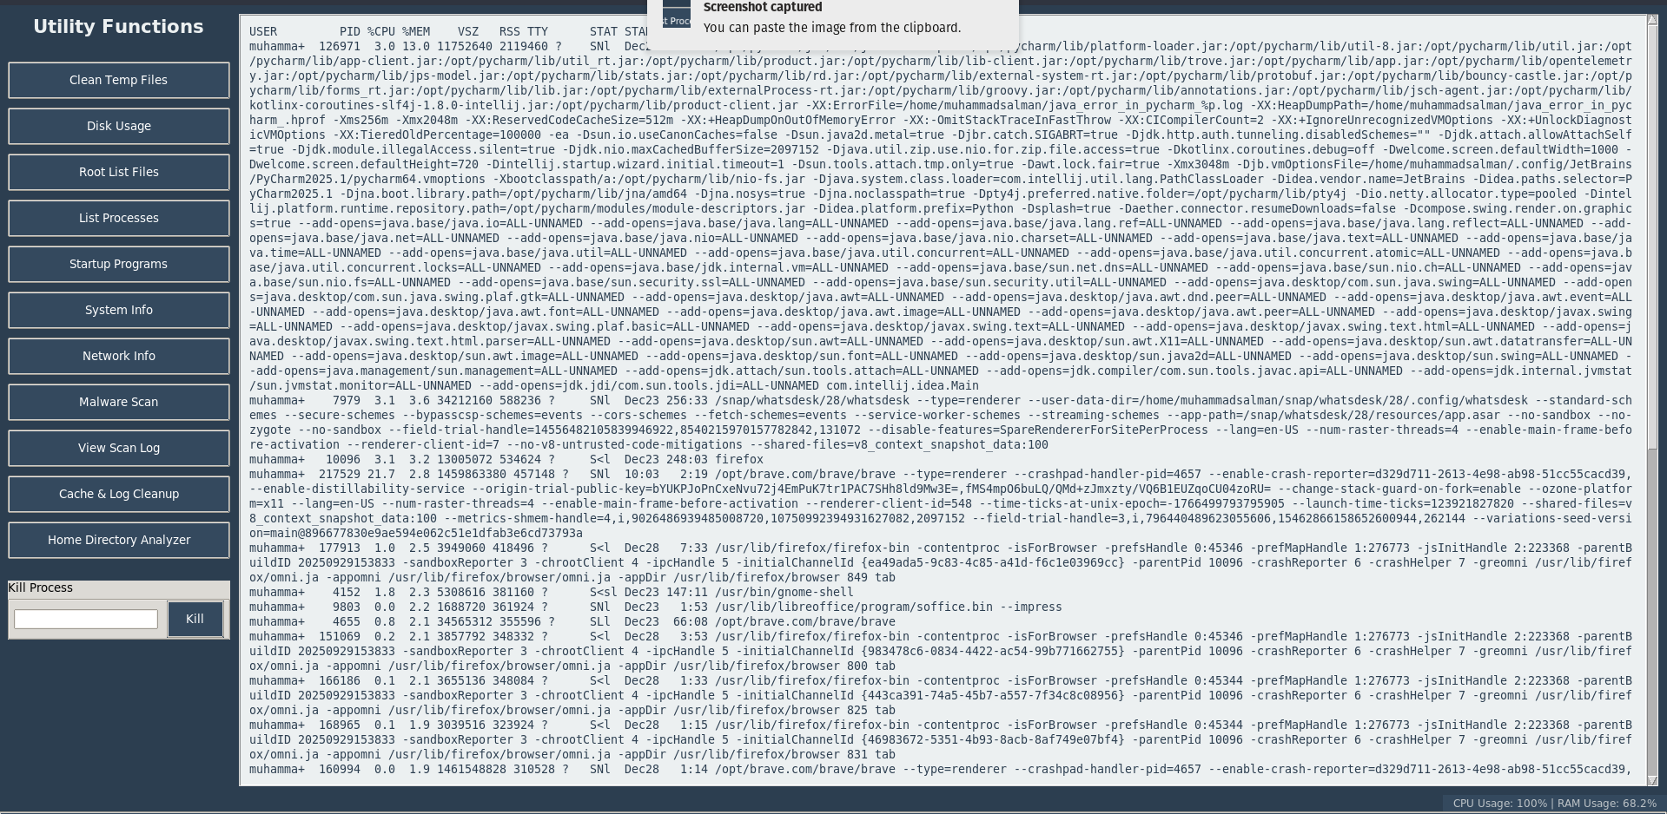
- System Calls: Executing commands using Python’s subprocess module.
- File System Operations: Recursive file deletion and permission handling.
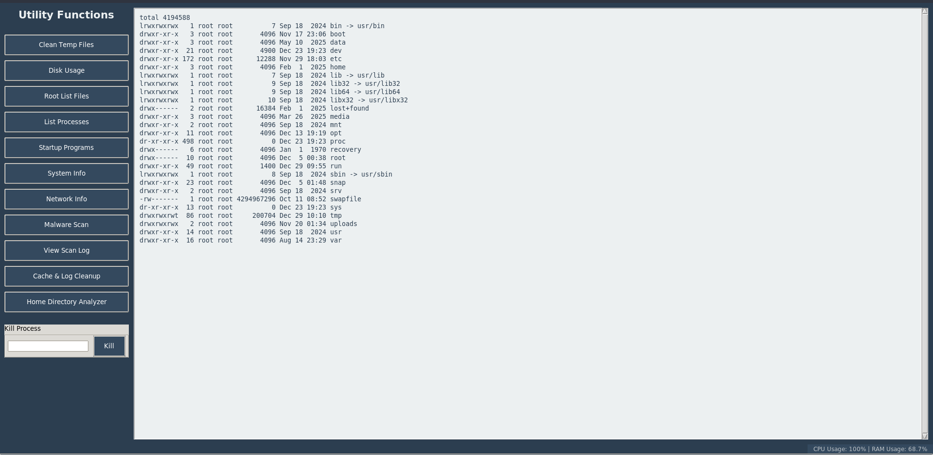
- Security Integration: Interfacing with system-level security tools.
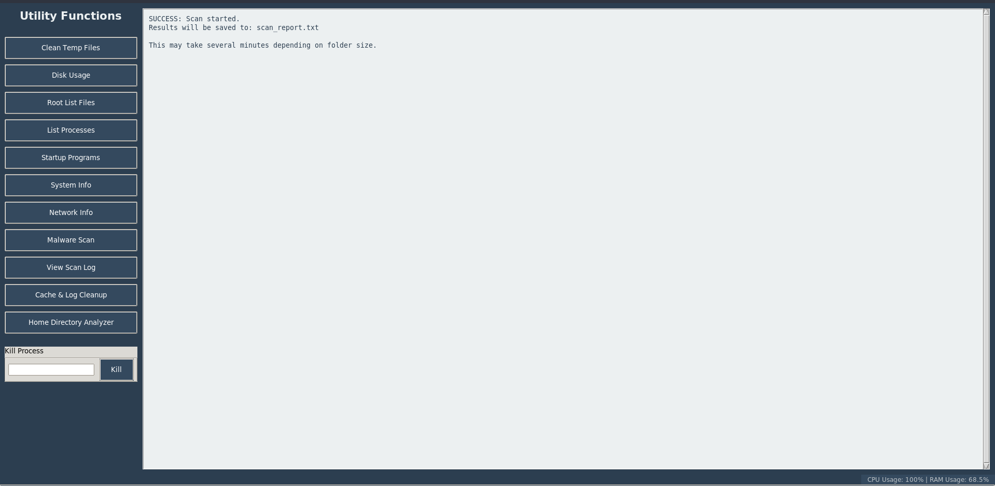
- Resource Monitoring: Acquiring real-time CPU, RAM, and disk usage statistics.
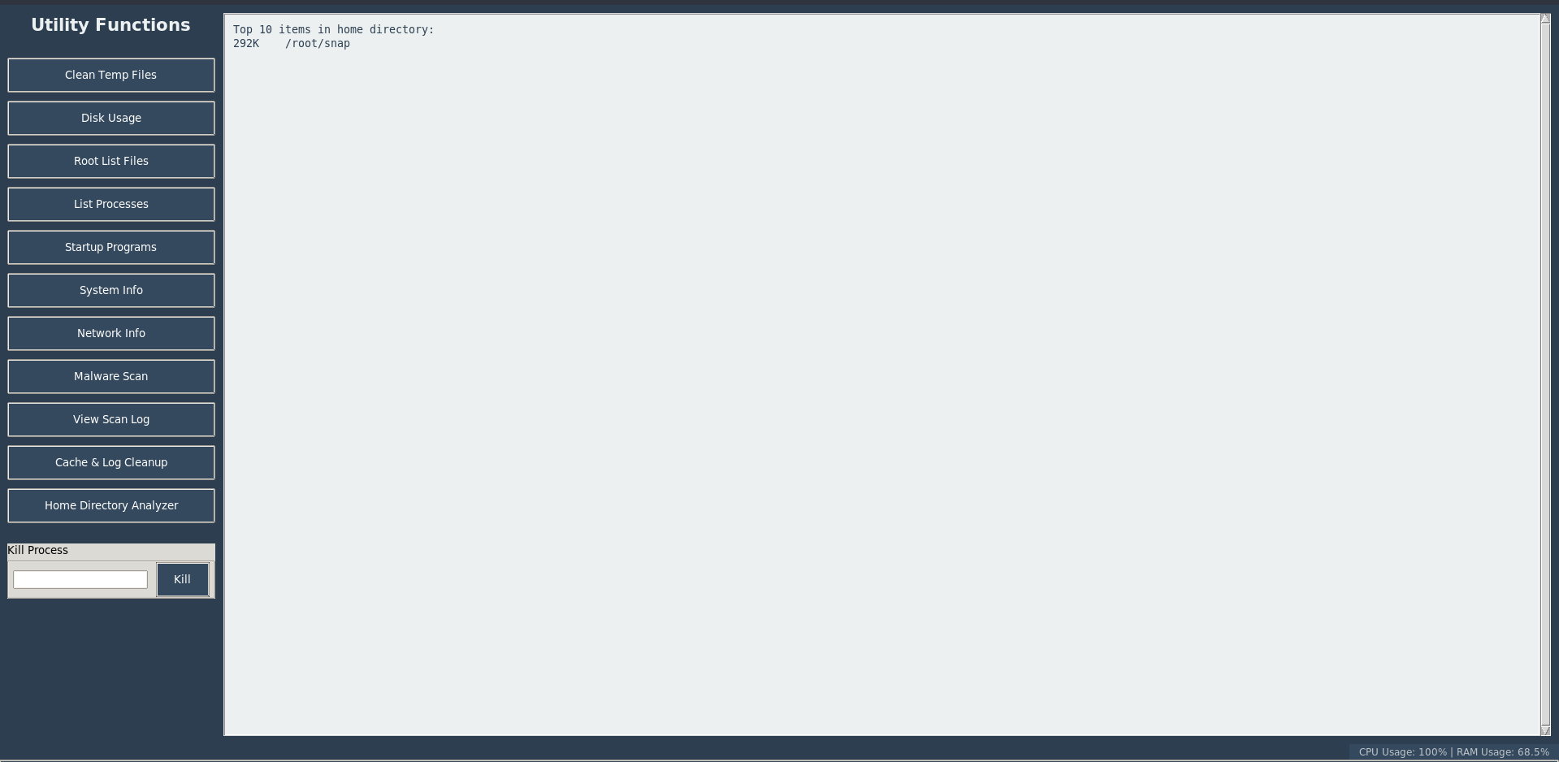

7. Results
The tool was tested on Windows 10 and Ubuntu 20.04 with the following outcomes:
- Successful cross-platform execution of file cleanup and process management.
- GUI rendered correctly and interacted seamlessly with OS-specific commands.
- Security modules successfully detected threats on both platforms using native scanners.

8. Future Work
- Expand compatibility to macOS.
- Add automated scheduling for tasks like cleanup and monitoring.
- Integrate advanced network monitoring tools (packet inspection).
- Implement detailed logging and reporting for all operations.

9. Conclusion
This project demonstrates that Python, combined with modular OS abstraction, can create a powerful cross-platform system utility tool. It provides essential OS functionalities with a user-friendly interface and shows practical application of OS concepts in process management and file operations.

10. References
- Python Documentation – https://docs.python.org/3/
- Tkinter Documentation – https://docs.python.org/3/library/tkinter.html
- Windows Command Line – https://learn.microsoft.com/en-us/windows-server/administration/windows-commands/
- Linux Commands – https://linux.die.net/man/

